Acadea Ticket Submission Agent
by Qupaca
Exec Brief | March 2026

1. Context & Background
This document is an exec brief identifying a significant pain point in the Acadea customer support process, and a solution that Qupaca (an AI workflow development agency led by Quinn) can develop for Acadea.

1.1 The Problem
When Acadea customers have a support issue or want a product customization, the intended process is straightforward: the customer submits a Zendesk ticket directly, and the Acadea support/dev team actions it.
That is not what happens. Instead:
- Customers call their CSM instead of submitting a ticket themselves.
- The CSM submits the ticket on the customer's behalf — but with degraded information.
- The dev/support team has follow-up questions, which they comment on the ticket.
- Those comments route back to the CSM, not the customer.
- The CSM relays the questions to the customer, gets answers, and re-enters the ticket thread.
- This telephone game repeats until the ticket has enough information to action.

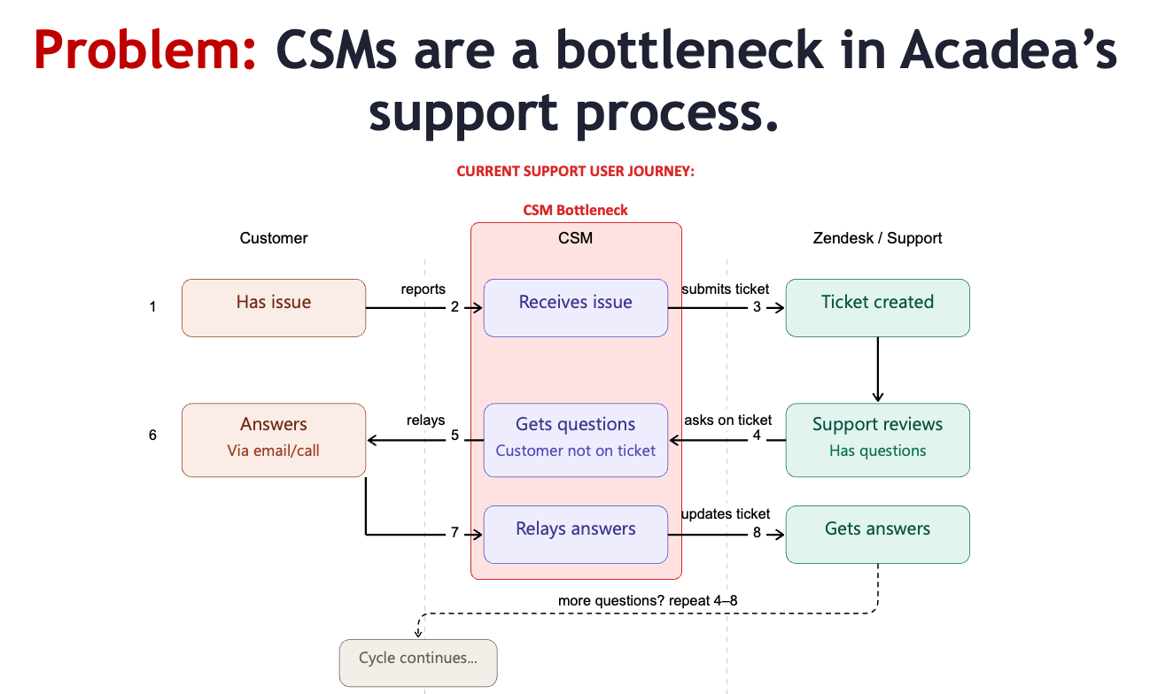
The result is lost context at every handoff, slow resolution times, CSM time wasted as middlemen, and frustrated customers and support staff.

1.3 Root Cause
Customers won't self-serve in Zendesk because the ticket submission UX is bad.
- The Zendesk UI is intimidating to non-technical users (primarily older staff at community colleges).
- Customers don't know what information the dev team needs — they lack technical empathy.
- Even the "Ticketing Best Practices" document Acadea wrote was too complex for some customers.
- Screenshot quality is a recurring problem, customers submit cropped screenshots without the URL bar.
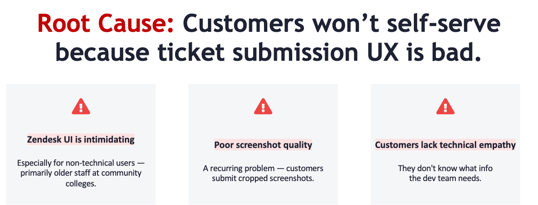

1.4 The Solution: AI Ticket Submission Agent
Qupaca will build a chat-based Agent that serves as the customer's interface for submitting tickets. The customer just talks. The agent does everything else.
Core agent responsibilities:
- Conduct a structured conversation to extract all information needed for a high-quality ticket.
- Validate screenshots uploaded by the customer (must include full browser window + URL bar).
- Apply a Ticketing Best Practices knowledge base using learnings from reviewing prior tix.
- Write and submit the final ticket to Zendesk on the customer's behalf via API.
- Ensure the ticket enables the dev team to work without needing to go back to the CSM.
The Customer is the context provider. The Agent is the technical translator. Support connects w/ the customer.
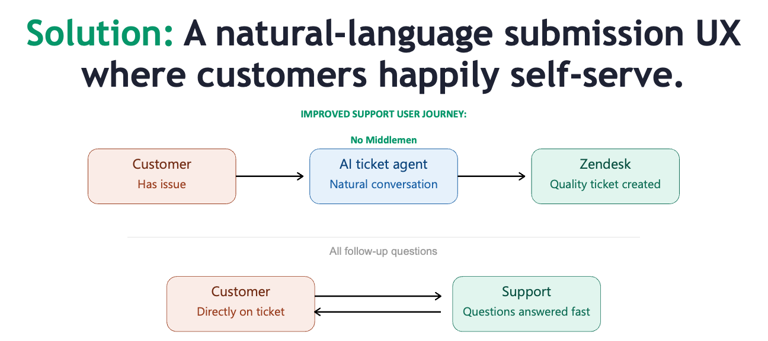

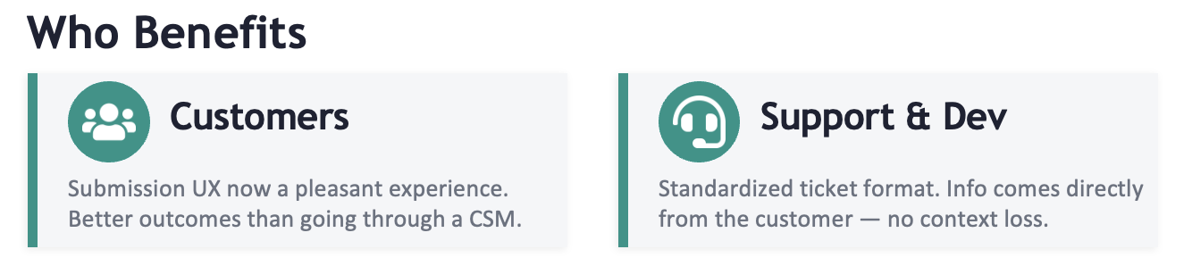

3. What We Can Build

3.1 Product Overview
A standalone, chat-based web application. The customer opens a link, optionally authenticates, and begins a natural language conversation with an AI agent. By the end of the conversation, a fully formatted, high-quality Zendesk ticket has been created on their behalf — without the customer ever touching Zendesk directly.

3.2 Key Features
- Chat-based conversational UI — no forms, no Zendesk login required during ticket creation.
- AI agent with Acadea Ticketing Best Practices baked into its system prompt (evolving markdown doc).
  - Screenshot validation — agent checks that uploaded screenshots include the full browser window and URL bar; prompts the customer to re-upload if not.
- Dynamic questioning — agent adapts follow-up questions based on the issue type being described.
- Ticket submission via Zendesk API — agent writes and submits the final ticket directly.
- Minimal Acadea dev lift — hosted and maintained entirely by Qupaca.

3.3 What the Agent Knows
The agent's knowledge will be bootstrapped from:
- Acadea's Ticketing Best Practices document.
  - Historical Zendesk tickets — especially the Q&A threads between support and customers/CSMs — so the agent understands what information support always needs.
- Product documentation, training materials, and demo recordings will be curated over time.
- Knowledge base lives as an editable markdown file(s), can be improved without a code deployment.
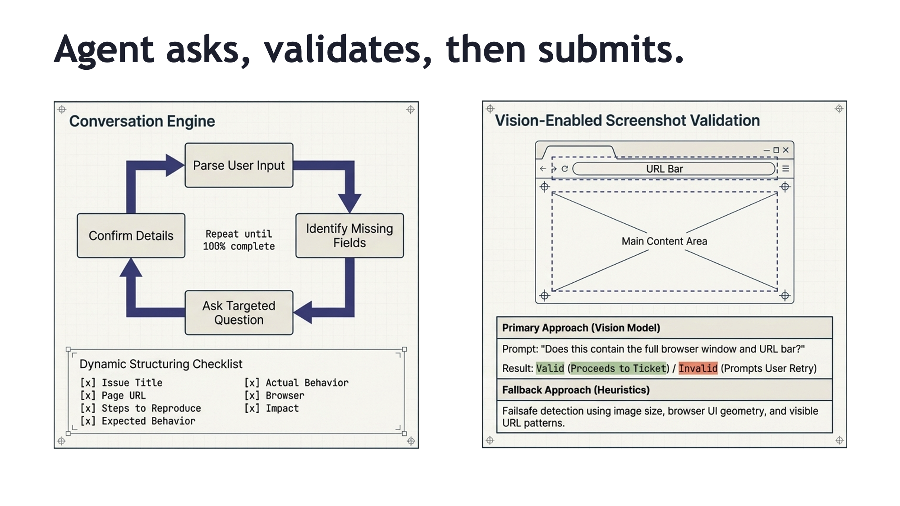

4. Timeline & Pricing

4.1 Timeline

Phase | Activity | Target
Pre-build | Acadea leadership greenlight; Open items resolved | Thurs Mar 19
Build Sprint | Core product built | Mar 19 – April 5
Design Partner Testing | Peralta + Chaffey test; debug | April 6 – April 17
Go-Live | Full rollout to all 64 customers. | April 20

4.1 Build Fee (Non-Recurring)
We will charge Acadea a one-time build fee of $2,500 based on estimated hours plus a significant New-Relationship discount.

4.2 Ongoing Operational Fee (Monthly Recurring)
After go-live, Acadea will pay a monthly operational fee of $160 to cover:
- Estimated LLM token costs per ticket submission
- Hosting and infrastructure costs
- Development work for maintenance

4.3 Commercial Philosophy
This is engagement #1. We believe if we do this well, there will be more.

